Power supplies
There are 5 connections, match the colors
RF connections
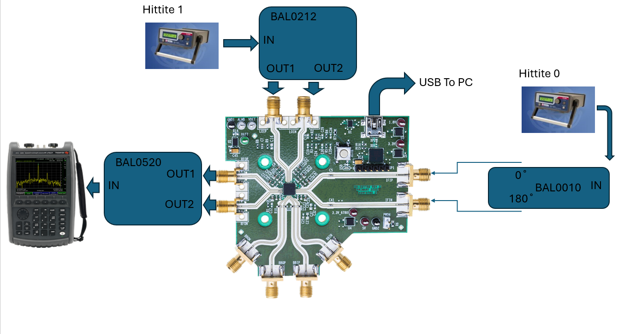
Other
USB to PC
Expected output
tone at 8GHZ

